The performance of the algorithm and the PID fully depend on sensors that are the eyes of the plant. How the car will perform depend on what the sensors read. No algorithm can tackle the noise that may be introduced by sensors in the system.

Initially we did our testing on the track made on a cardboard. Although the car ran on the track successfully as on 14-aug-2010, but still satisfactory performance was not achieved, due to the inconsistent nature of the sensors.

As the materials used on the racing track are still not known, so we decided to understand our sensors better before moving on further. This way we will be able to tackle various disturbances that may occur in the racing track.

TODO

* Check the reliability of sensor values at different time intervals without disturbing the system.
* Test the effect of tube light on sensor readings without disturbing the system.
* Test and calibrate all sensors one by one.
* Check the effect of distance on sensor values.
* See how the values get affected, if we increase the thickness of black tape.
* Check the effect of TV remote on sensors or some other IR source.
* See if could somehow detect the orientation of the car at different possible cases during the race. This would be like gold to us.
* See if increasing resolution helps and calculate the time taken for the ATD conversion of both 8bit and 16bit ATD conversion.

Conclusions

* We should calibrate values of sensors on the racing track and then use limit bound algorithms to tackle high and low values that may occur
* The sensor values are completely precise if no disturbance affects the system.
* There is no affect of tube light on sensor values.

How Sensors fit in

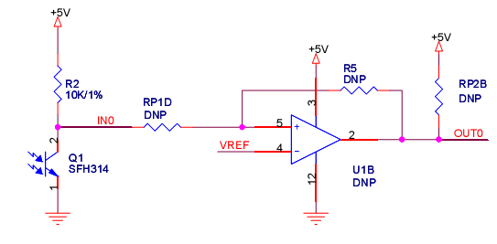

The IR receiver is SFH314.

The IR radiation details

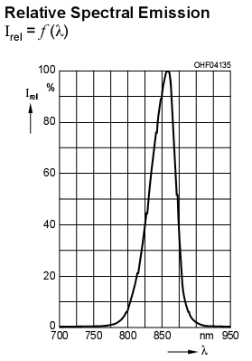

It is clear in the above cited figure that, the IR emitted is notably in the range 800 nm to 900 nm. Now we need to do some research on the properties of this range of IR radiation.

|  |  |
| --- | --- |
| IR emitted range | 800-900nm |
| IR receiver sensitivity range | 460-1080nm (850 most sensitive) |
| Most sensitive angle | 10 deg |
|  |  |

IR Receiver characteristics

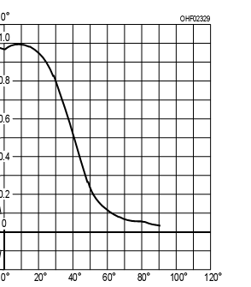

**Distance is very large (no reflection)**

235 234 240 231 235 230 234 236

**When tubelight is turned off**

183 067 045 050 035 048 053 097

183 067 045 050 035 048 053 097

**Tube on**

183 067 044 050 035 047 052 096

183 067 044 050 035 047 053 096